**OS Assignment 6**

Hamza Shahid

20p-0117

BSSE-4A

**Task 01:**

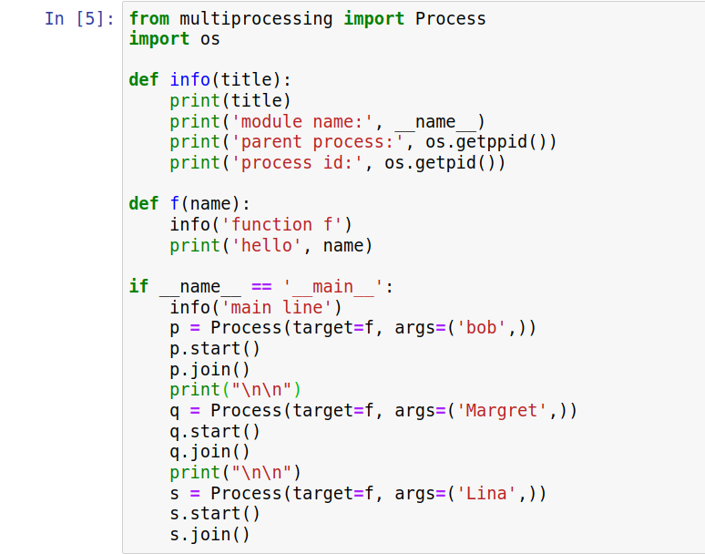

**Output:**

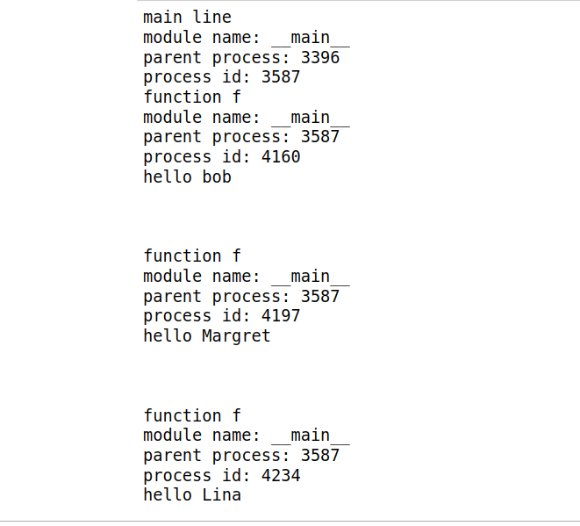

**Explanation:**

Process function creates a process and it takes 2 arguments. One is the name of the function to be called and the other is the argument for that function. Then we have to start the process by the start function.